Title (Times New Roman, bf, fs 14, centered)
(empty line)
Author^{a.}, Presenting Author^{b}, Author^{c}
(empty line)
ªInstitution or Company a, Full Address
^{b}Institution or Company b, Full Address
^{c}Institution or Company c, Full Address
(empty line)
E-mail address corresponding author
(empty line)
(empty line)
Margins: top, right, left: 2,5 cm, bottom: 2 cm
Title: Times New Roman (TNR), boldface (bf), fontsize (fs) 14, single line spacing (sls), centered. The title should not contain more than 200 characters.
Authors: TNR, regular (r), fs 11, sls, centered. Given Name Family Name, underline presenting author. Superscripts ª, ^{b}, ^{c}, ... for affiliations.
Affiliations: TNR, r, fs 9, sls, centered.
E-mail address corresponding author (replace this with the e-mail address): TNR, r, fs 11, sls, left.
Main text: TNR, r, fs 11, sls, justify. Reference numbers in square brackets, e.g. [1,3-4]. Please do not use footnotes. Seperate paragraphs by a blank line. Figures or images should be inserted as jpeg or tiff format files.
Figure and table captions: Calibri, italic, fs 10, aligned with the figure/table.
References: TNR, r, fs 9, sls, left. State author names as: Initials. Family name.
(empty line)
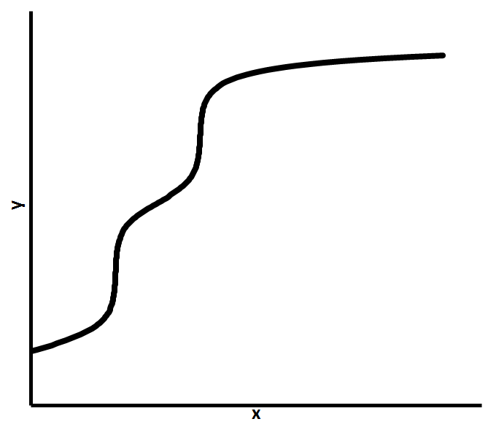
Fig. 1. Curve plot
(empty line)
The abstract should be written in English. It must not exceed one page.

Please submit your abstract in Portable Document Format (.pdf) via the conference website. Recommended file name: the presenting author's family name followed by his/her initials typed in small letters, e.g. "smithta.docx" for T. A. Smith. Add numbers, if necessary (smithta1.docx).
(empty line)
(empty line)
References
[1] Authors (M. T. Nguyen-Kim, T. A. Smith), Journal title Year, Volume, Pages.
[2] Authors, Book title, Editors, Publisher, City (Year).

